 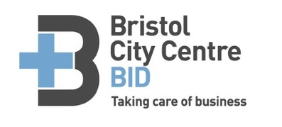

Old City Business Event 2017

AGENDA

Tuesday 7th February 5:00pm

**Walkabout**

40 Corn St, Bristol BS1 1HQ

* Welcome, thank you and apologies
* **BID** update

social media BID + Old City

* **St Nick’s market and Love Food Festival**

To explore feasibility and local business interest in utilising space on St Nicholas Street to extend the event into the Old City.

* **Old City** business news
* AOB
* Next meeting date