 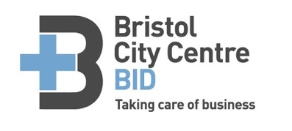

Park Street Traders and Business Forum 2016

**AGENDA**

Monday 18th April 2016

2:30p.m. to 3:30p.m.

***The Prince Street Social***

* BID plan progress:
* Update on the BID area and future direction
* Radio Net System
* Social media
* Events 2016
* **Spirini**, Nathan Measures
* **Barnardo’s**,Sue Wheeler
* Questions
* Next meeting date

