 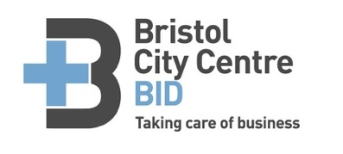

**Old City Traders and Business Forum 2016**

**AGENDA**

Tuesday 23rd August 2016

2:30p.m. to 3:30p.m.

**Mr Wolfs (yoga studio)**

32, St Nicholas St, Bristol BS1 1TG

* BID update
* Social media
* Radio Net System
* Events
* Updates on various changes and road closures.
* AOB
* Next meeting date

