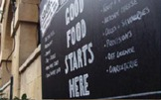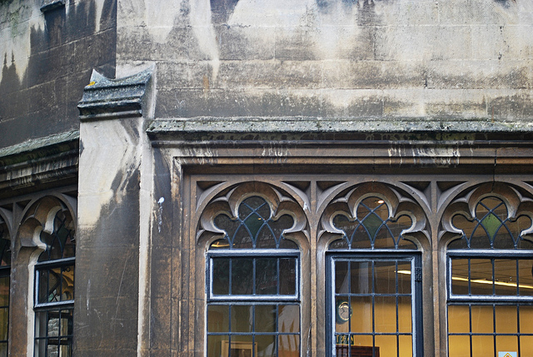

You are invited to

OLD CITY TRADERS’ & BUSINESS FORUM

DATE AND TIME: Tuesday, 4th March 2014, 6.00 – 8.00pm

LOCATION: Bagel Boy, 39-41 St Nicholas Street

With spring finally on its way the meeting will be an opportunity for you to get an idea of all the major events that are planned for the Old City this year, and how you can get involved.

Very excitingly, the meeting will also give a sneak-preview of the much anticipated Old City Walking Guide, and, as always, will provide useful updates on current projects in and around Old City.

AGENDA
- Welcome, Introductions, Apologies, Agenda Review – 5 min
- Welcome and Intro from Bagel Boy – 5 min
- BCC update re Budget & Public Realm – 20 min
- Old City Walking Guide Pre-Launch and intro of Traders’ Postcards – 25 min
- Intro to Sacred Land – 10 min
- Old City Events and how to get involved – 20 min
  - BIG Green Week and Biggest Market
  - Make Sunday Special
  - Bristol Walking Festival
  - Bristol Food Connections
  - Others
- Energy Bulk Buying – 10 min
- Intro to Docmail – 5 min
- News and Questions – 10 min
- AOB – 5 min
- Next steps and date of next meeting – 5 min

Even if you haven’t been to any of the previous meetings please get involved and help to further improve the business environment for the Old City traders.

I look forward to seeing many of you on 4th March – RSVP would be helpful. In the meantime please don’t hesitate to contact me if you have got any questions or ideas.

With very best wishes,
Eva
Eva Stuetzenberger
Retail Sector Development Manager
Post: The Management Suite, 69 Broadmead, Bristol, BS1 3DX
Tel: 0117 929 0484
Email: eva.stuetzenberger@destinationbristol.co.uk
Twitter: @RetailProject

