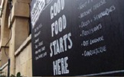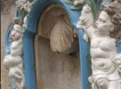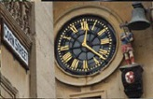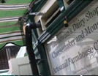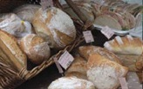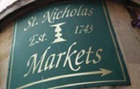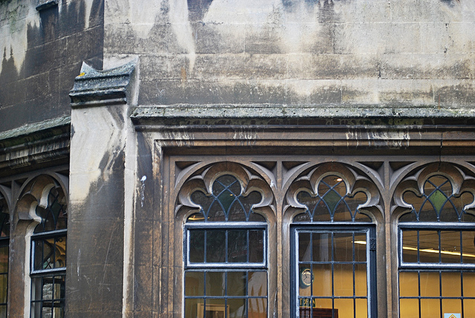

You are invited to

OLD CITY TRADERS’ & BUSINESS FORUM

DATE AND TIME: Tuesday, 10th September 2013, 6.00 – 8.00pm

LOCATION: Church of St John the Baptist, Broad Street, BS1 2EZ

Our next meeting will be at St John the Baptist, one of Bristol’s most historic churches, built into the city walls in the 14th century, and part of the very fabric of the Old City. Thank you to Emma from The Churches Conservation Trust for inviting us to experience this remarkable building - we might even have time at the end to explore the depths of its vaulted crypt.

AGENDA

- Welcome, Introductions, Apologies, Agenda Review – 5 min
- Intro to St John the Baptist and The Churches Conservation Trust – 5 min
- Old City Public Realm Improvements; update – 20 min
including Corn Street Pedestrianisation, Gateways, De-cluttering, Waste
- Old City traditional shop signs; proposal – 10 min
- Old City animation strategy; discussion – 10 min
- Old City walking route; update – 10 min
- New Bridewell; development proposal - 20 min
- Bristol Pound; update – 10 min
- Old City news & events – 15 min
- AOB – 10 min
- Date of next meeting – 5 min

I look forward to seeing many of you on 10th September – RSVP would be helpful.

In the meantime please don’t hesitate to contact me if you have got any questions or ideas.

With very best wishes,

Eva

Eva Stuetzenberger
Retail Sector Development Manager
Post: The Management Suite, 69 Broadmead, Bristol, BS1 3DX
Tel: 0117 929 0484
Email: eva.stuetzenberger@destinationbristol.co.uk
Twitter: @RetailProject


