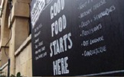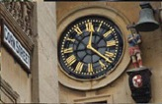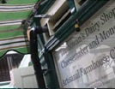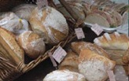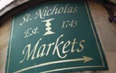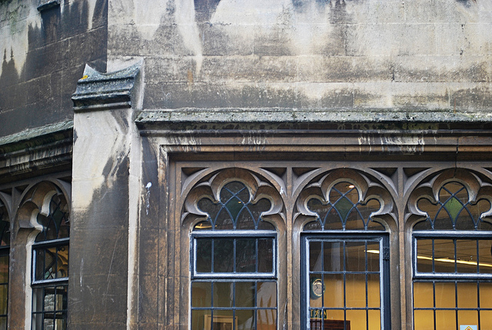

You are invited to

OLD CITY TRADERS’ & BUSINESS FORUM

DATE AND TIME: Tuesday, 15th October 2013, 6.00 – 8.00pm

LOCATION: The Birdcage, 28 Clare Street, Bristol, BS1 1YE

Our next meeting will be at the newly refurbished “Birdcage”. Thank you to Georgina and Lauren from the Birdcage for inviting us to experience “Yesterday’s Clothes, Today’s Coffee, Tomorrow’s Music” as a backdrop for our Old City Traders’ & Business Forum.

It is the time of year again when Christmas features highly on the agenda – together with many other interesting points as you can see below:

AGENDA

- Welcome, Introductions, Apologies, Agenda Review – 5 min
- Old City Public Realm Improvements; update – 20 min
- Traffic reducing options for Old City
- Old City in the Bristol Central Area Plan; discussion – 15 min
- Reminder of consultation
- Using space above commercial premises
- Old City traditional shop signs; progress and next steps – 10 min
- “Cut it Out” – Police Christmas Campaign/Event; proposal – 20 min
- Shop Local This Christmas initiative – 5 min
- New Placemaking Awards for Old City – 5 min
- Old City walking route; update – 10 min
- Old City news & events – 15 min
- AOB – 5 min
- Date of next meeting – 5 min

I look forward to seeing many of you on 15th October – RSVP would be helpful.

In the meantime please don’t hesitate to contact me if you have got any questions or ideas.

With very best wishes,

Eva

Eva Stuetzenberger
Retail Sector Development Manager
Post: The Management Suite, 69 Broadmead, Bristol, BS1 3DX
Tel: 0117 929 0484
Email: eva.stuetzenberger@destinationbristol.co.uk
Twitter: @RetailProject

