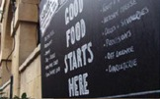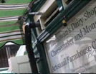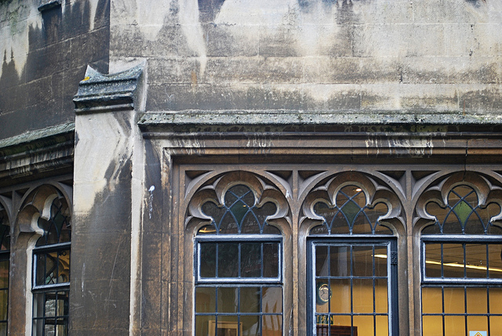

You are invited to

OLD CITY TRADERS’ & BUSINESS FORUM

DATE AND TIME: Tuesday, 21st January 2014, 6.00 – 8.00pm

LOCATION: Café Revival, 56 Corn Street

Our first meeting of 2014 with much to update on and lots to get our teeth stuck in.

AGENDA

- Welcome, Introductions, Apologies, Agenda Review – 5 min
- Welcome and Intro from Café Revival – 5 min
- Old Vic development plans – 30 min
- Public Realm and Metrobus update – 20 min
- Old City walking guide update – 10 min
- Shop sign update – 5 min
- MyHigh.St update – 5 min
- Business Rates and Discretionary Rate Relief news – 10 min
- Funding opportunities – 5 min
- News/Events, Updates, Questions – 15 min
- AOB – 5 min
- Next steps and date of next meeting – 5 min

Even if you haven’t been to any of the previous meetings please make 2014 the year to get involved and help to further improve the business environment for the Old City traders.

I look forward to seeing many of you on 21st January – RSVP would be helpful.

In the meantime please don’t hesitate to contact me if you have got any questions or ideas.

With very best wishes,

Eva

Eva Stuetzenberger
Retail Sector Development Manager
Post: The Management Suite, 69 Broadmead, Bristol, BS1 3DX
Tel: 0117 929 0484
Email: eva.stuetzenberger@destinationbristol.co.uk
Twitter: @RetailProject

