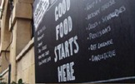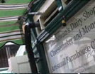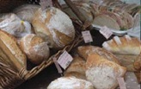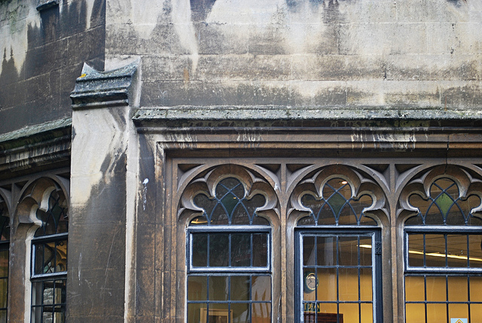

You are invited to

OLD CITY TRADERS’ & BUSINESS FORUM

DATE AND TIME: Thursday, 4th September 2014, 6.00 – 8.00pm

LOCATION: The Cosy Club, 31 Corn Street, Bristol BS1 1HT

After a short summer break, our September meeting will take stock of our work so far and look ahead at projects for the rest of the year and beyond.

As you can see below, we have a packed and varied agenda, plus, as always, a forum for discussion and networking – this time in the opulent surroundings of the new Cosy Club.

AGENDA
- Welcome, Introductions, Apologies, Agenda Review – 5 min
- Welcome from Cosy Club – 5 min
- Castle Park Improvement Project – 15 min
- Public Realm Project and Baldwin Street Cycle Scheme Update – 10 min
- Old City Website Upgrade – 10 min
- Creative Partnership Projects – 10 min
- Intro to Wriggle App – 10 min
- Markets Team News – 10 min
- Make Sunday Special and Events Update – 10 min
- Funding Opportunities – 10 min
- Planning / Developments – 10 min
- News and Questions – 5 min
- AOB – 5 min
- Next steps and date of next meeting – 5 min

I look forward to seeing many of you on 4th September – RSVP would be helpful.

In the meantime please don’t hesitate to contact me if you have got any questions.

With very best wishes,

Eva

Eva Stuetzenberger
Retail Sector Development Manager
Post: The Management Suite, 69 Broadmead, Bristol, BS1 3DX
Tel: 0117 929 0484
Email: eva.stuetzenberger@destinationbristol.co.uk
Twitter: @RetailProject

