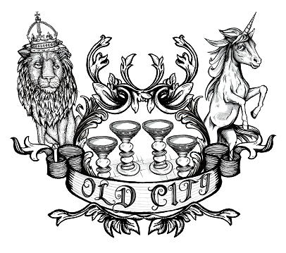
You are invited to

OLD CITY TRADERS’ & BUSINESS FORUM

DATE AND TIME: Thursday, 6th November 2014, 6.00 – 8.00pm

LOCATION: Playground Coffee House, 45 St Nicholas Street

Our autumn meeting will give an update on ongoing projects and will look at the Green Capital year ahead, and the opportunities this provides for Old City. As always, the meeting will be a forum for discussion and networking – this time in the quirky surroundings of Playground Coffee House.

AGENDA
- Welcome, Introductions, Apologies, Agenda Review – 5 min
- Welcome from Playground – 5 min
- Public Realm Project and Baldwin Street Cycle Scheme Update – 20 min
- Waste Policy Update - 10 min
- Bristol 2015 Green Capital Opportunities (and other funding) – 10 min
- Creative Partnership Projects (Craftspeople in Old City) – 10 min
- Intro to Travel West Support for Sustainable Travel – 10 min
- Markets Team News – 10 min
- Events Update – 10 min
- Planning and Development – 10 min
- News and Questions – 10 min
- AOB – 5 min
- Next steps and date of next meeting – 5 min

I look forward to seeing many of you on 6th November – RSVP would be helpful.

In the meantime please let me know if you have got any questions or ideas.

Best wishes,

Eva

Eva Stuetzenberger
Retail Sector Development Manager
Post: The Management Suite, 69 Broadmead, Bristol, BS1 3DX
Tel: 0117 929 0484
Email: eva.stuetzenberger@destinationbristol.co.uk
Twitter: @RetailProject

