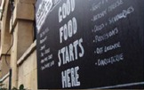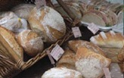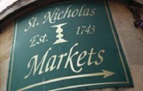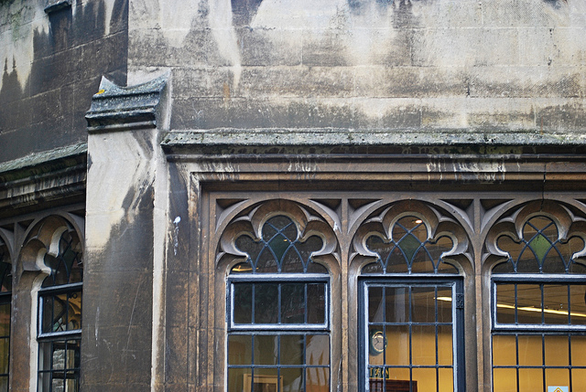

You are invited to

OLD CITY TRADERS’ & BUSINESS FORUM

DATE AND TIME: Thursday, 8th May 2014, 6.00 – 8.00pm

LOCATION: Copper Jacks Crafthouse, 30 Clare Street

We will meet at Copper Jacks to hear about an exciting new planning application for the venue. Also interesting news from local businesses (including Cosy Club, Creative Youth Network, Tesco), an events update following the 1st Make Sunday Special, and much more – plus, as always, a forum for discussion and networking.

AGENDA
- Welcome, Introductions, Apologies, Agenda Review – 5 min
- Copper Jacks planning proposal for Boutique Hostel – 20 min
- Intro to Creative Youth Network at The Station – 10 min
- Intro to Cosy Club in Corn Street – 10 min
- Tesco Community Engagement opportunities – 10 min
- Public Realm Project update – 10 min
- Old City Traders’ Postcards (and Walking Guide) – 10 min
- Shipshape Magazine proposal – 10 min
- Bristol Pound Tourist Map – 10 min
- Markets and Events update – 10 min
- News and Questions – 5 min
- AOB – 5 min
- Next steps and date of next meeting – 5 min

Even if you haven’t been to any of the previous meetings please get involved and help to further improve the business environment for Old City traders.

I look forward to seeing many of you on 8th May – RSVP would be helpful.

In the meantime please don’t hesitate to contact me if you have got any questions.

With very best wishes,

Eva

Eva Stuetzenberger
Retail Sector Development Manager
Post: The Management Suite, 69 Broadmead, Bristol, BS1 3DX
Tel: 0117 929 0484
Email: eva.stuetzenberger@destinationbristol.co.uk
Twitter: @RetailProject

