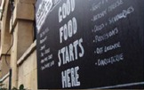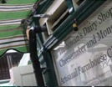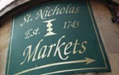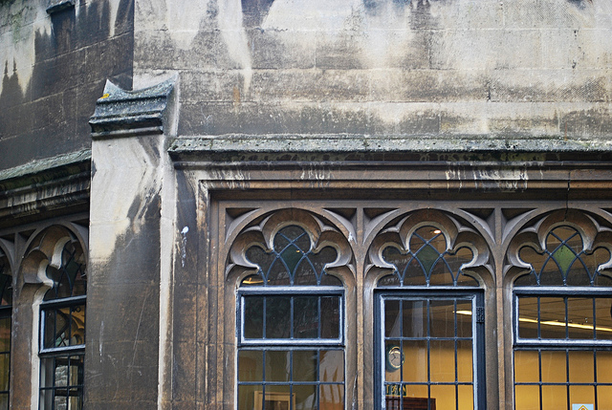

You are invited to

OLD CITY TRADERS’ & BUSINESS EVENING

DATE AND TIME: Tuesday, 4th June 2013, 6.00 – 8.00pm

LOCATION: The Grand Thistle Hotel, Broad Street

Our next meeting will take place at the Grand Thistle Hotel in Broad Street, by kind invitation of the General Manager, Mark Kelly.

As you can see below, the agenda for the meeting is as diverse as the Old City itself: from the latest traffic proposals, to news about funding won for an Old City walking route; a look at exciting plans for some Old City properties; and info about an array of events and activities soon to animate the area.

AGENDA
- Welcome, introductions and info from the Grand Thistle – 10 min
- Agenda review – 5 min
- Old City cycling improvements; options – 20 min
- Old City Public Realm improvements; update – 20 min
Including Corn Street traffic, Gateways, De-cluttering, Waste
- 30-36 St Nicholas Street development – 15 min
- Old City Walking Route Project
  - Sacred City walking route; St Stephen’s - 10 min
  - Interpretation of route; Bristol Civic Society – 10 min
  - Walled Market and other Leonard Lane Events; Centrespace – 10 min
- Guildhall Arts Centre – The largest Pop Up in the UK? – 10 min
- Old City Events – 5 min
- AOB – 5 min
- Date of next meeting

Please come along and share your views.

I look forward to seeing many of you on 4th June – RSVP would be helpful.

In the meantime please don’t hesitate to contact me if you have got any questions.

With very best wishes,

Eva

Eva Stuetzenberger
Retail Sector Development Manager
Post: The Management Suite, 69 Broadmead, Bristol, BS1 3DX
Tel: 0117 929 0484
Email: eva.stuetzenberger@destinationbristol.co.uk
Twitter: @RetailProject


