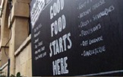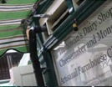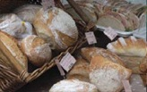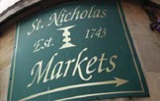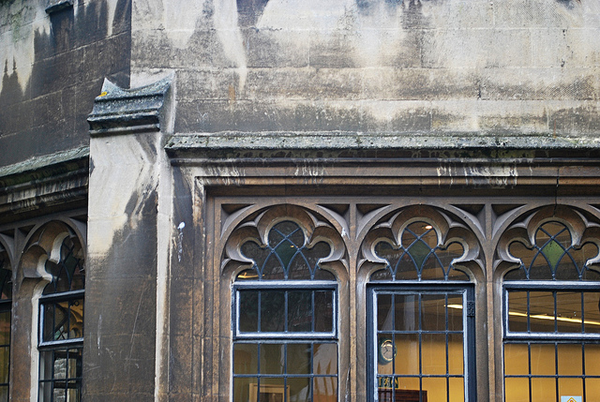

You are invited to

OLD CITY TRADERS’ & BUSINESS EVENING

DATE AND TIME: Thursday, 18th July 2013, 6.00 – 8.00pm

LOCATION: Bespoke Wild At Heart, 51 Broad Street

Our next meeting will take place at “Bespoke Wild At Heart”, by kind invitation of the team at the exciting new salon.

Our Mayor George Ferguson will be attending the meeting for a Question & Answer session, following the myriad of amazing developments and events in Old City recently.

AGENDA
- Welcome, Introductions, Apologies, Agenda Review – 5 min
- Q&A session with Mayor George Ferguson – 25 min
- Old City Public Realm Improvements; update – 20 min
including Corn Street Pedestrianisation, Gateways, De-cluttering, Waste
- BCC Waste Services & Street Scene; info – 10 min
- Old City Walking Route Project; update – 10 min
- Old City News & Events – 10 min
- Independents Initiatives “Market Place” – 30 min
  - New Independents Campaign “Trading Tales”
  - Bristol Pound
  - YourStreet gift card
  - My High.St
- AOB – 10 min
- Date of next meeting

NB: Please send any questions you would like to ask the Mayor to me by Monday, 15th July 2013. I will then collate the questions and put them forward to the Mayor at the meeting. This way we can ensure that all your issues can get addressed in the half hour session that’s available.

I look forward to seeing many of you on 18th July – RSVP would be helpful.

In the meantime please don’t hesitate to contact me if you have got any questions or ideas.

With very best wishes,

Eva

Eva Stuetzenberger
Retail Sector Development Manager
Post: The Management Suite, 69 Broadmead, Bristol, BS1 3DX
Tel: 0117 929 0484
Email: eva.stuetzenberger@destinationbristol.co.uk
Twitter: @RetailProject


