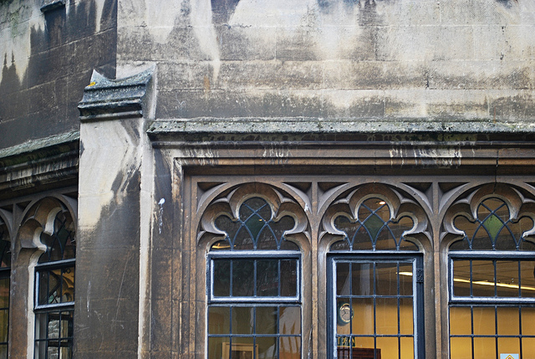

You are invited to

OLD CITY TRADERS’ & BUSINESS EVENING
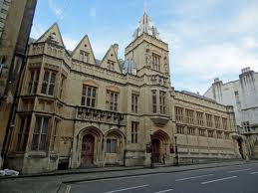
DATE AND TIME: Tuesday, 30th April 2013, 6.00 – 8.00pm

LOCATION: The Guildhall, Entrance Small Street

Our much anticipated next meeting will take place at the Guildhall, by kind invitation of Trevor Osborne.

After an exclusive tour to the building the meeting will update on upcoming developments and initiatives for Old City and provide a forum for discussion, networking, and getting involved.

AGENDA

- Welcome and introductions – 5 min
- Agenda review – 5 min
- Tour to Guildhall and Guildhall progress report – 45 min
- Make Sunday Special initiative – 10 min
- Old City cycling improvements – 10 min
- Old City Public Realm project next steps – 25 min
- Corn Street pedestrianisation and animation
- De-cluttering & Waste
- Your Street gift card – 15 min
- AOB – 5 min
- Date of next meeting

Please come along and share your views.

I look forward to seeing many of you on 30th April – RSVP would be helpful.

In the meantime please don’t hesitate to contact me if you have got any questions.

With very best wishes,

Eva

Eva Stuetzenberger
Retail Sector Development Manager
Post: The Management Suite, 69 Broadmead, Bristol, BS1 3DX
Tel: 0117 929 0484
Email: eva.stuetzenberger@destinationbristol.co.uk
Twitter: @RetailProject


